**DAILY ONLINE ACTIVITIES SUMMARY**

|  |  |  |  |  |  |  |  |  |
| --- | --- | --- | --- | --- | --- | --- | --- | --- |
| **Date:** | **1-6-2020** | | | | | **Name:** | **Prajna** | |
| **Sem & Sec** | **8th sem ‘B’** | | | | | **USN:** | **4AL16CS067** | |
| **Online Test Summary** | | | | | | | | |
| **Subject** | | **SMS** | | | | | | |
| **Max. Marks** | | **60** | | **Score** | | | **60** | |
| **Certification Course Summary** | | | | | | | | |
| **Course** | **Front end development html** | | | | | | | |
| **Certificate Provider** | | | **Great Learning** | | **Duration** | | | **30min** |
| **Coding Challenges** | | | | | | | | |
| **Problem Statement:**1**.** Write a python program to find the second largest number. | | | | | | | | |
| **Status: Completed** | | | | | | | | |
| **Uploaded the report in GitHub**  **GitHub link:** | | | | | **Yes**  **https://github.com/alvas-education-foundation/prajna_k** | | | |
| **If yes Repository name** | | | | | **prajna_k** | | | |
| **Uploaded the report in slack** | | | | | **yes** | | | |

Online Test Details: (Attach the snapshot and briefly write the report for the same)

Certification Course Details: (Attach the snapshot and briefly write the report for the same)

Coding Challenges Details: (Attach the snapshot and briefly write the report for the same)

1)online test

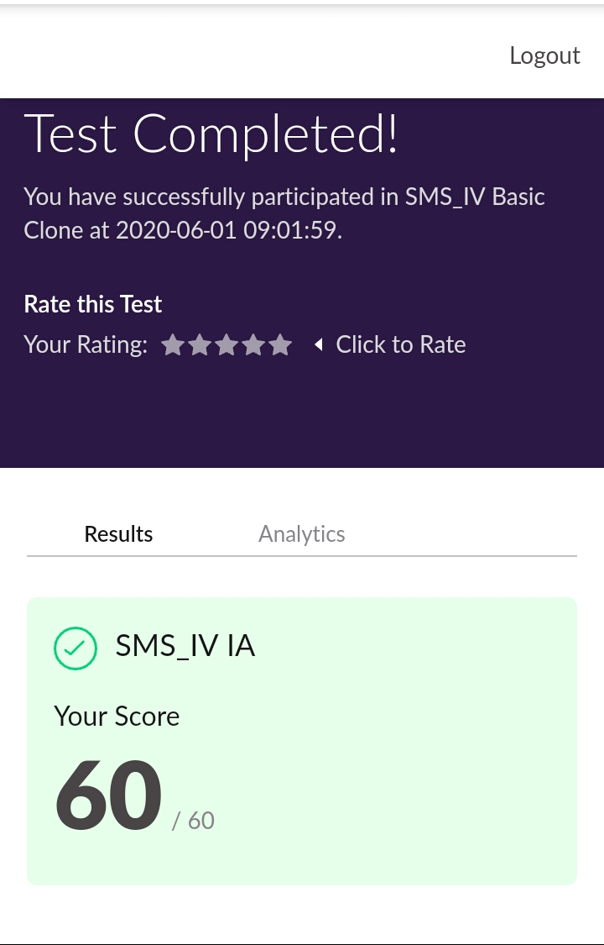

2) certification course

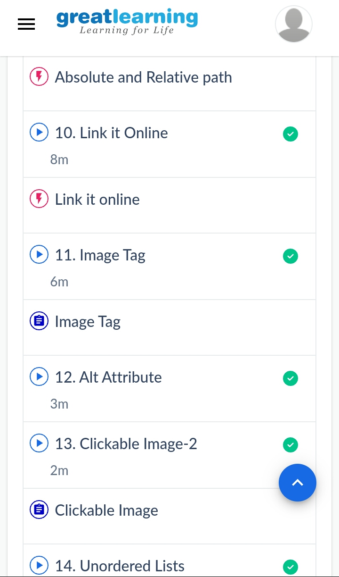

3) coding challenges

Program 1

list1 = [10, 20, 4, 45, 99]

mx=max(list1[0],list1[1])

secondmax=min(list1[0],list1[1])

n =len(list1)

for i in range(2,n):

if list1[i]>mx:

secondmax=mx

mx=list1[i]

elif list1[i]>secondmax and mx != list1[i]:

secondmax=list1[i]

else:

if secondmax == mx:

secondmax = list1[i]

print("Second highest number is : ",str(secondmax))

|  |
| --- |
|  |
|  |  |
|  |  |
|  |  |
|  |  |
|  |  |